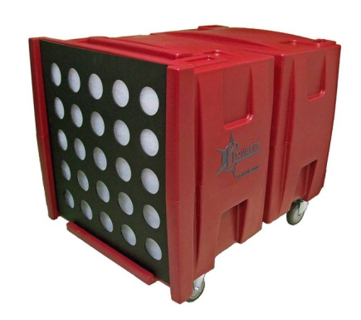
The Novair F2105
"The complete package!" Our most powerful, durable & light weight Negative Air Machine available! Virtually Indestructible!
FEATURES AND BENEFITS:
• Powerful 2HP motor generates exceptional, consistent flow rate and utilizes all filter media area
• 2 speed motor-provides consistent air flow of 2000cfm (high speed) and 1000cfm (low speed)
• 8 point motor/cage mounting prevents motor and cage shifting under the harshest conditions
• Seamless construction guarantees leak proof operation
• One of the lightest 2000cfm units on the market is easily transported by 2 operators
• Positive lock filter prevents filter movement for uninterrupted filtration
• Uses standard 24" x 24" H.E.P.A. filters, rated 99.97% efficiency against 0.3 micron particles
• General Purpose Filters & Audible Alarms are also available
• Custom controls & features available upon request
F2105 | 118lbs | 37" x 26" x 31" | 2HP-Two Speed,  Thermally Protected | High-2000cfm  Low-1200cfm | 115Volt  15 Amp, 60Hz | 1/2" Pad / Ring Filter

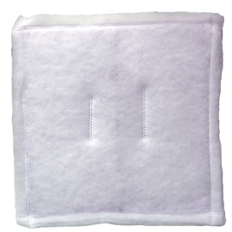 | 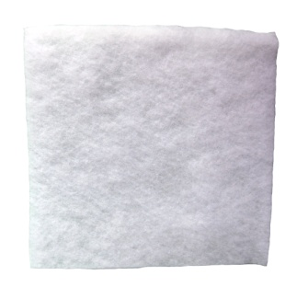 |  | 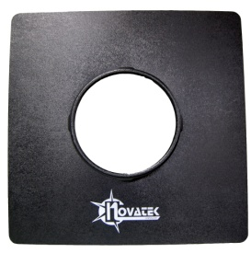 | 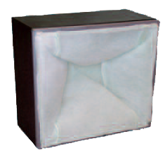
Ring Filters  Part No: 55014 | Pad Filter  Part No: 55007 |  | 12" Vacuum Intake Door  Part No: A31091 | General Purpose Filter Kit  Part No: A30176  Replacement General Filter Only: A40023

